Lab: Text Processing
Problems for exercise and homework for the "JS Fundamentals" Course @ SoftUni.
Submit your solutions in the SoftUni judge system at: https://judge.softuni.org/Contests/1705

Print Characters
Write a function that receives a string and prints all the characters on separate lines.

Input / Output
Input | Output
'AWord' | A  W  o  r  d
'Sentence' | S  e  n  t  e  n  c  e

Hints
Loop through the string and print each character.
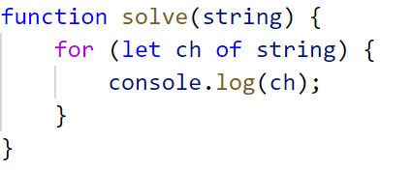

Substring
Write a function that receives a string and two numbers. The numbers will be a starting index and count of elements to substring. Print the result.

Input / Output
Input | Output
'ASentence', 1, 8 | Sentence
'SkipWord', 4, 7 | Word

Hints
Create a new string that takes the needed amount of elements from the given string.
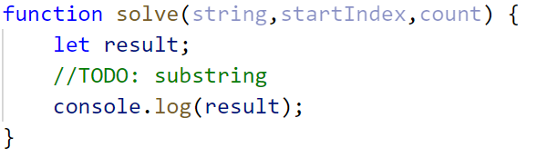

Censored Words
Write a function that receives a text as a first parameter and a single word as a second. Find all occurrences of that word in the text and replace them with the corresponding count of '*'.

Input / Output
Input | Output
'A small sentence with some words', 'small' | A ***** sentence with some words
'Find the hidden word', 'hidden' | Find the ****** word

Hints
Save the new text in a new variable.
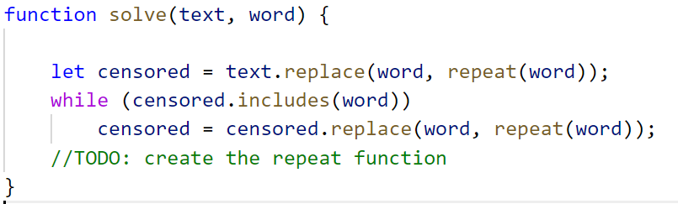
The repeat() function should take the length of the word and return that amount of stars '*'.

Count String Occurrences
Write a function that receives a text and a single word that you need to search. Print the number of all occurrences of this word in the text.

Input / Output
Input | Output
'This is a word and it also is a sentence',  'is' | 2
'softuni is great place for learning new programming languages',  'softuni' | 1

Hints
Split the sentence into words and create a counter that stores how many times the searched word occurs.
